Project Design Phase-II: Data Flow & User Stories

Data Flow Diagram (DFD)
The following Data Flow Diagram illustrates the journey of a culinary query through the Flavour Fusion ecosystem. It maps the transition from a simple user idea to a professionally formatted blog post ready for publication.

Key Data Transitions:
- User Input: The "Citizen Blogger" provides a recipe topic (e.g., "Japanese Fusion Tacos") and a word count target.
- Prompt Engineering (Process 1.1): The system enriches the user's input with structural instructions (e.g., "Include prep time, ingredients, and a 3-paragraph intro") to ensure the AI output meets blogging standards.
- Authentication & API Call (Process 1.2): The system securely retrieves the GEMINI_API_KEY and transmits the payload to Google’s Gemini-2.5-Flash model.
- Generative Processing: The AI generates a Markdown-formatted response, ensuring a logical flow from ingredients to instructions.
- Interactive Rendering (Process 1.3): While data is in transit, the UI triggers a "Jokes & Facts" stream to keep the user engaged.
- Final Output: The processed Markdown is rendered as a clean, structured blog post on the Streamlit interface.
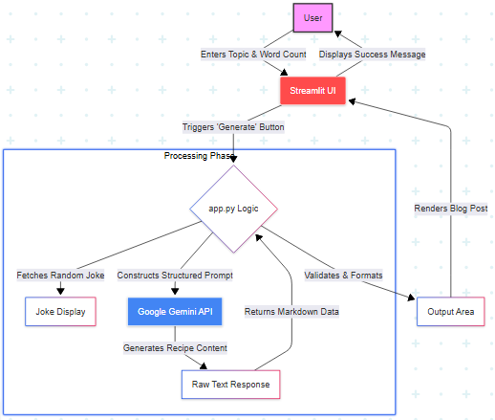

For Content Creators & Bloggers
- As a food blogger, I want to specify a target word count so that the generated content fits my website's SEO requirements and layout.
- As a busy creator, I want to see entertaining content like programmer jokes while the AI is generating my recipe so that the wait time feels shorter and more engaging.
- As a culinary writer, I want the AI to include cooking tips and recipe variations so that my blog post provides more value to my readers than a simple instruction list.
- As a non-technical user, I want to input a simple recipe topic and receive a fully formatted Markdown response so that I don't have to spend time on manual styling and headers.

For Home Cooks & Enthusiasts
- As a home cook, I want the AI to generate clear, step-by-step instructions so that I can follow the recipe easily without confusion.
- As a dietary-restricted cook, I want to input specific constraints (like "Vegan" or "Gluten-Free") in the topic field so that the AI generates recipes safe for my needs.

